Goto AWS>EC2 instance

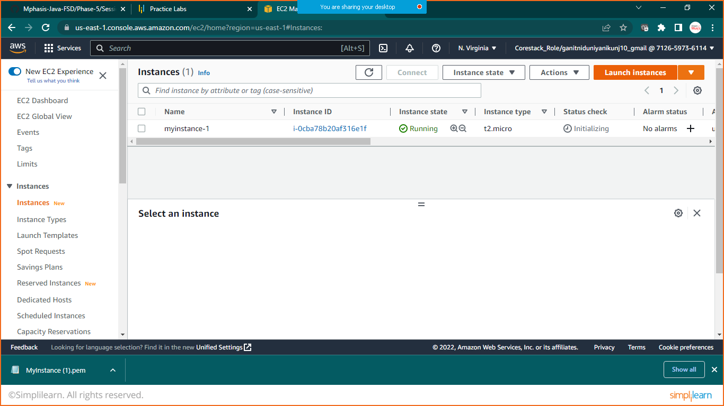

Click on Launch Instance

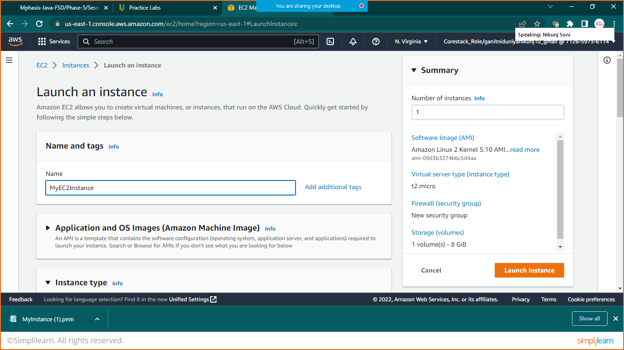give the name

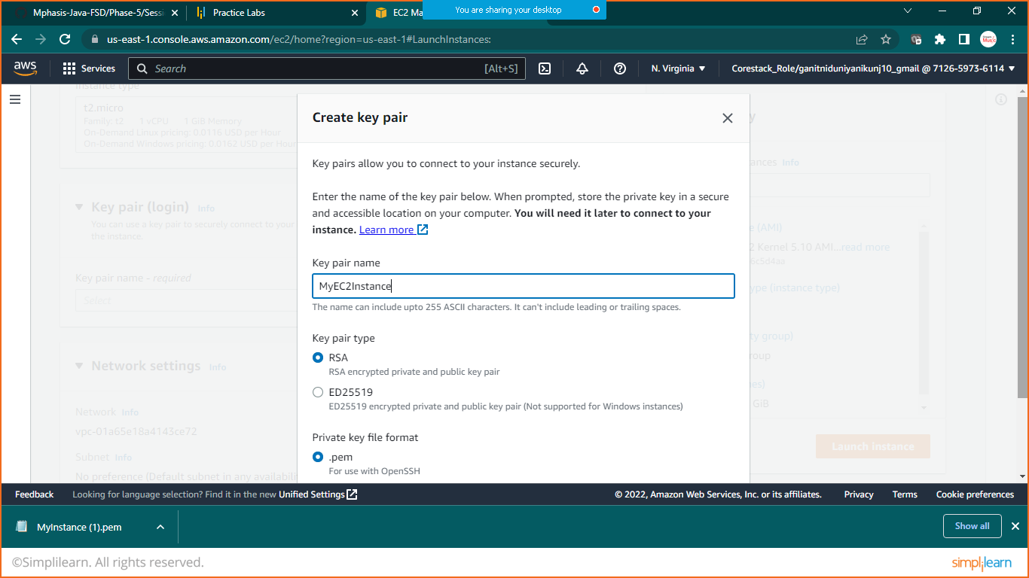

Create key value pair

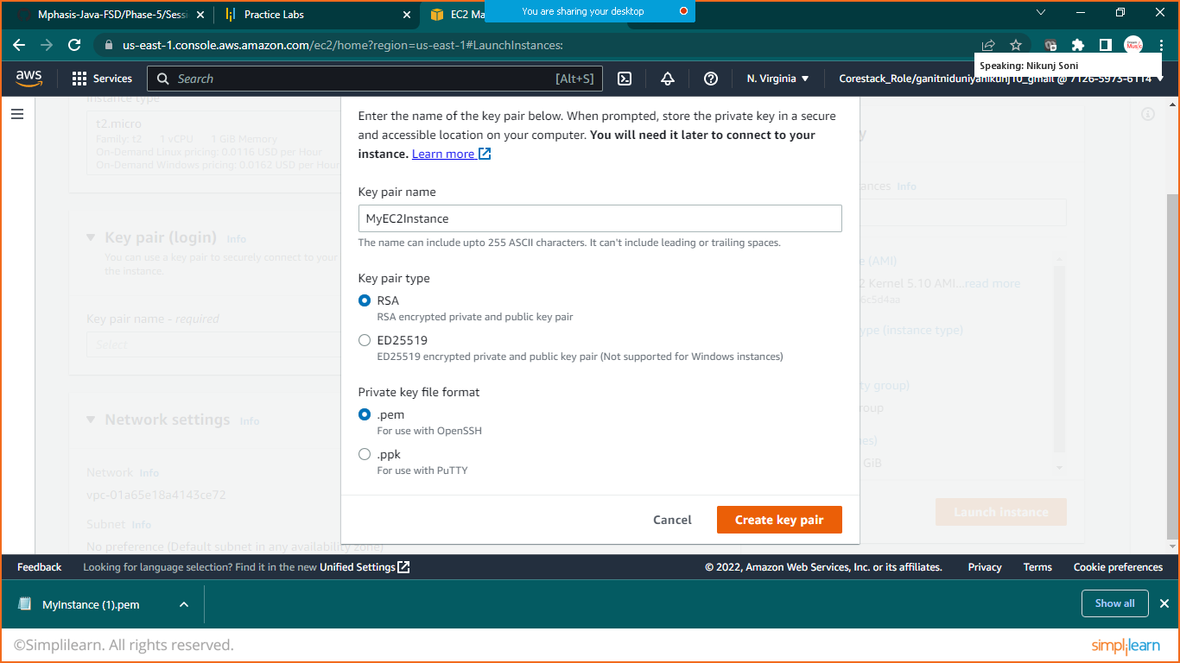

Download .pem file and move to the desire directory

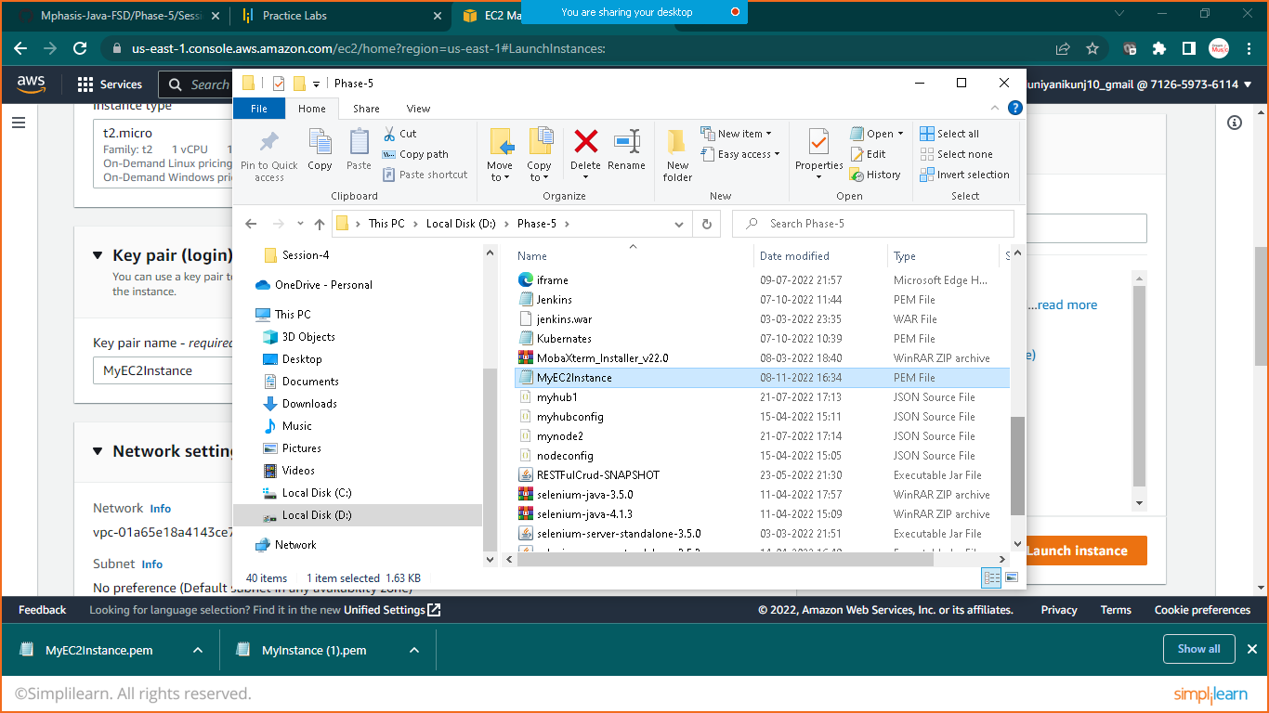

For me I have moved to D:\phase-5 folder

Now in Network Settings click on EDIT

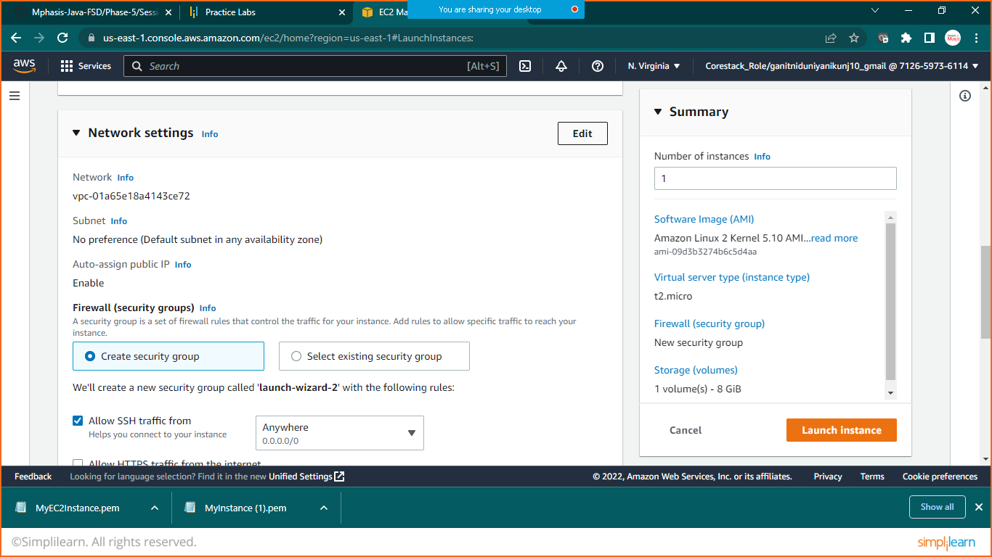

Click on add security group role

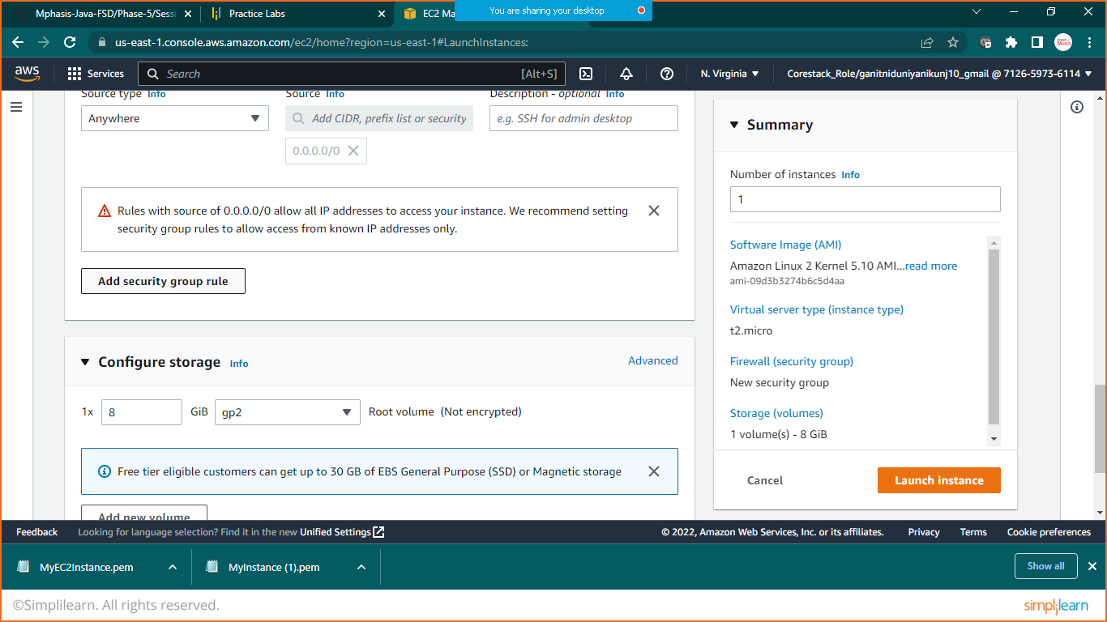

Add port number

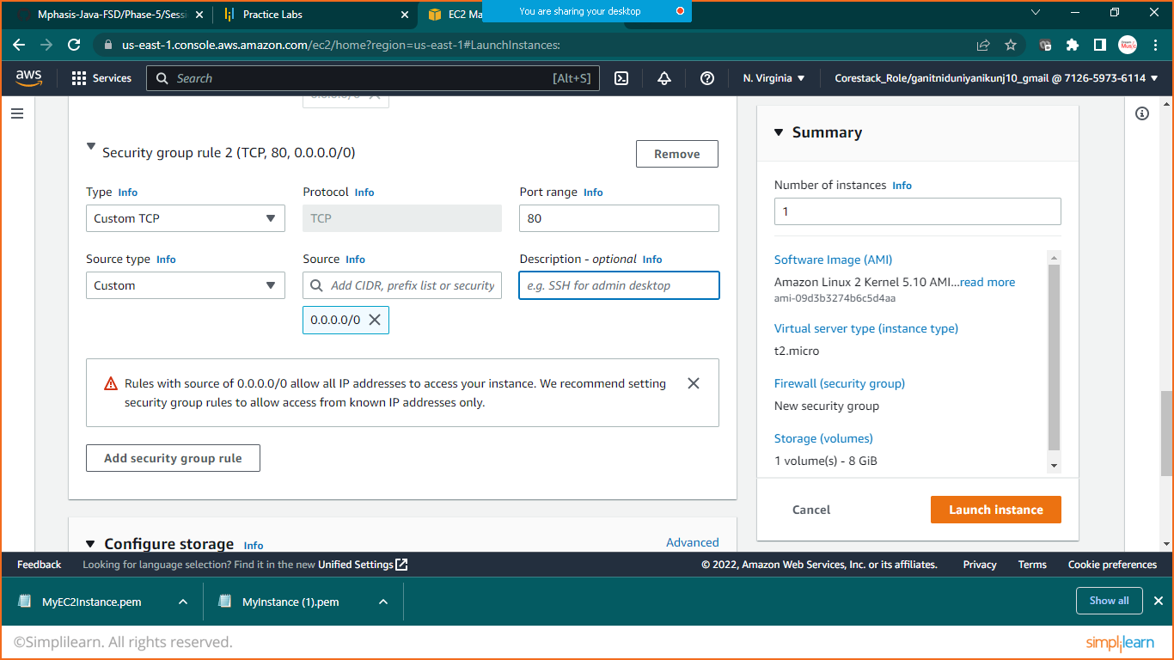

Click on launch instance

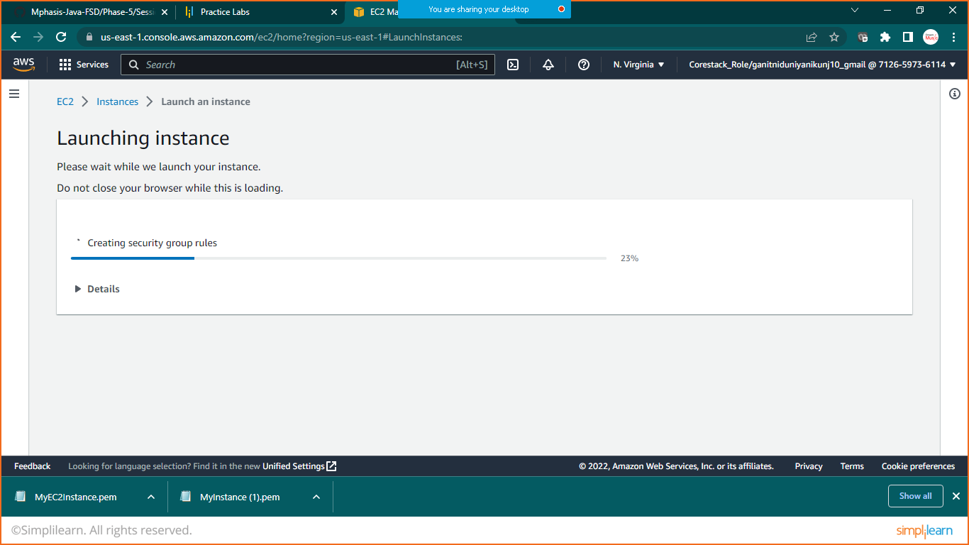

DOWNLAOD MOBA X-TERM

LINK: <https://mobaxterm.mobatek.net/download.html>

GOTO>AWS>EC2INSTANCE>SELECT YOUR INSTANCE>CONNECT>COPY SSH EXAMPLE KEY

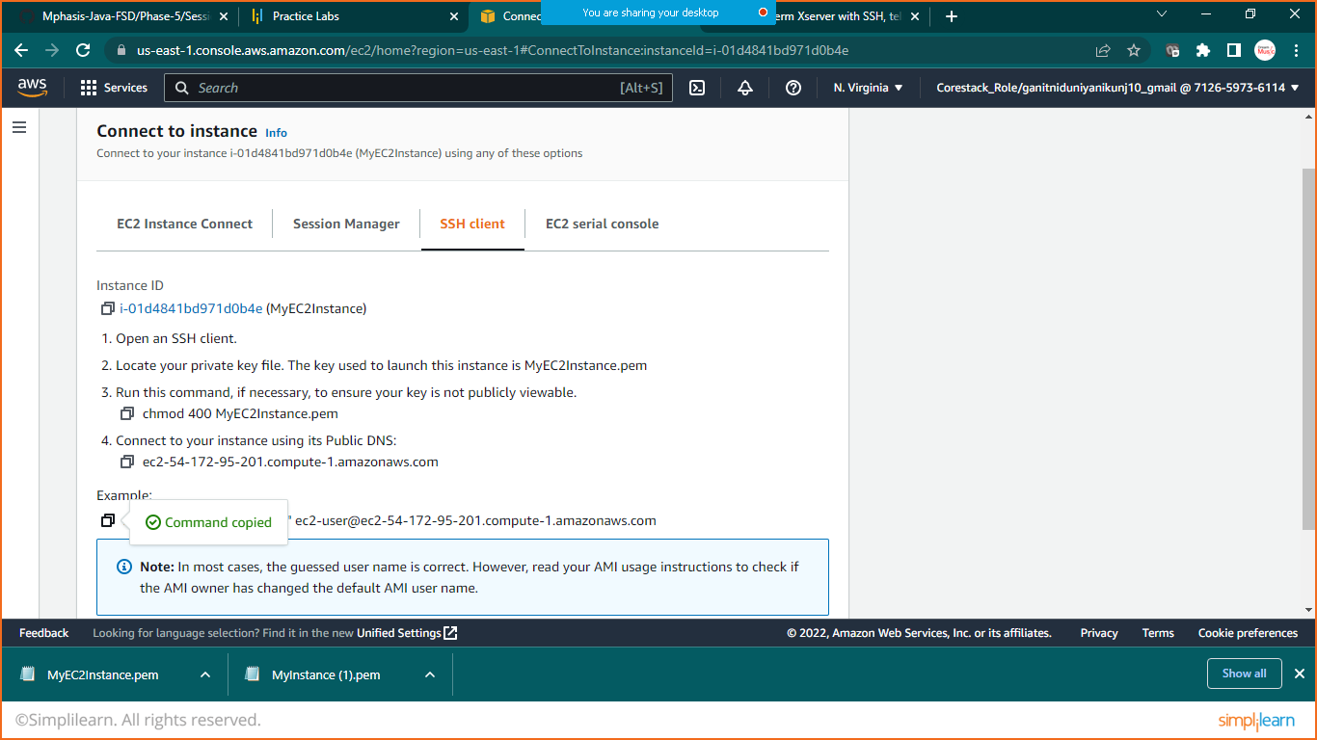

OPEN MOBA X-TERM

Now move to the folder where you had downloaded .pem

key

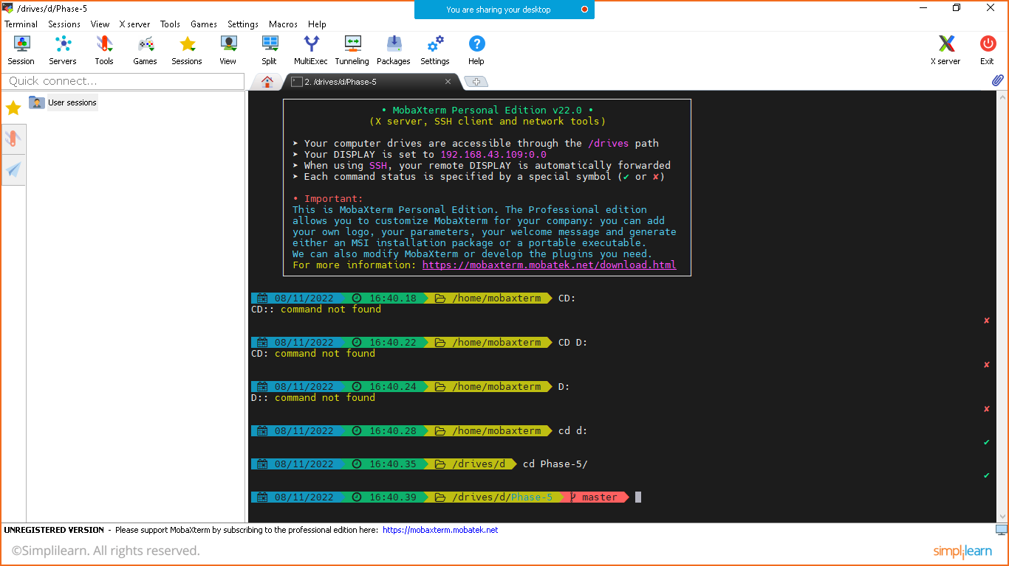

Paste ssh key here to connect

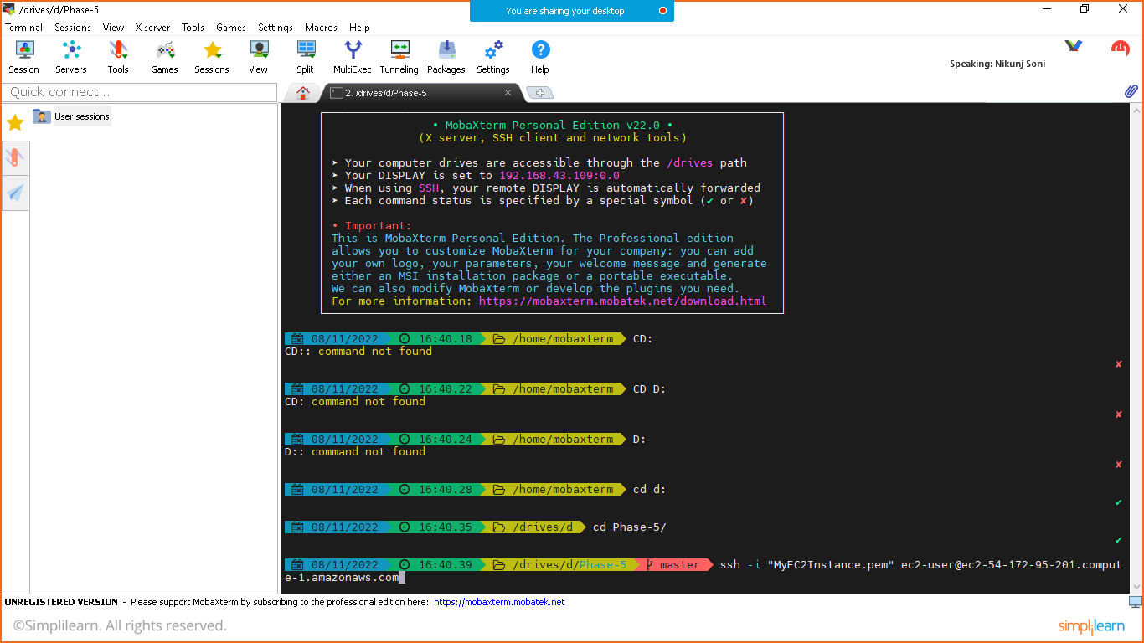

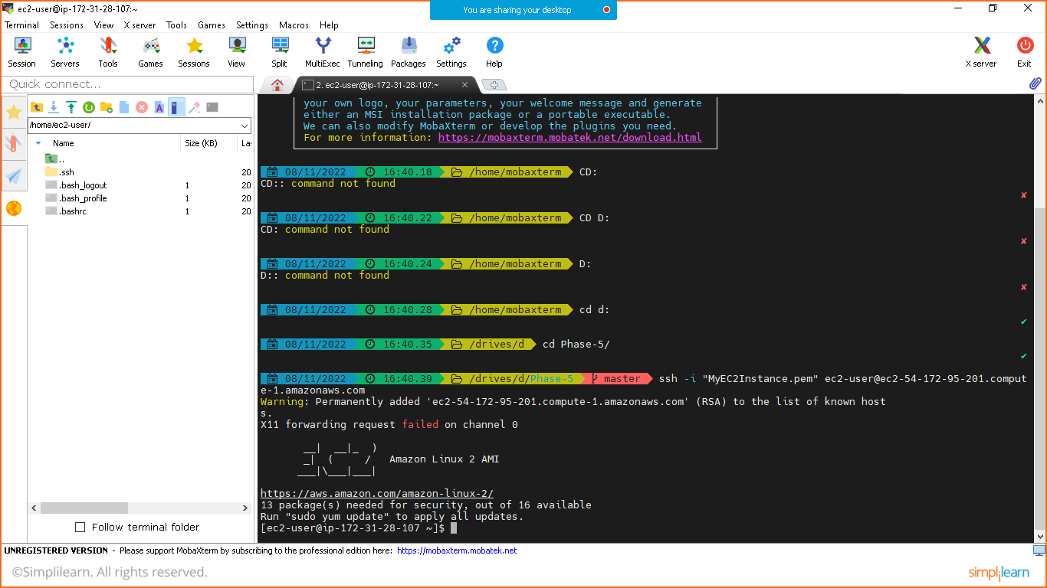

PREPARE INDEX.HTML PAGE

* sudo su –
* yum install httpd –y
* cd /var/www/html
* vi index.html

press ‘i’ to insert into html page

<h1>WELCOME TO AWS CLOUD</h1>

Press ‘esc’

* :wq!

Hit enter button

* service httpd start
* curl localhost

output:

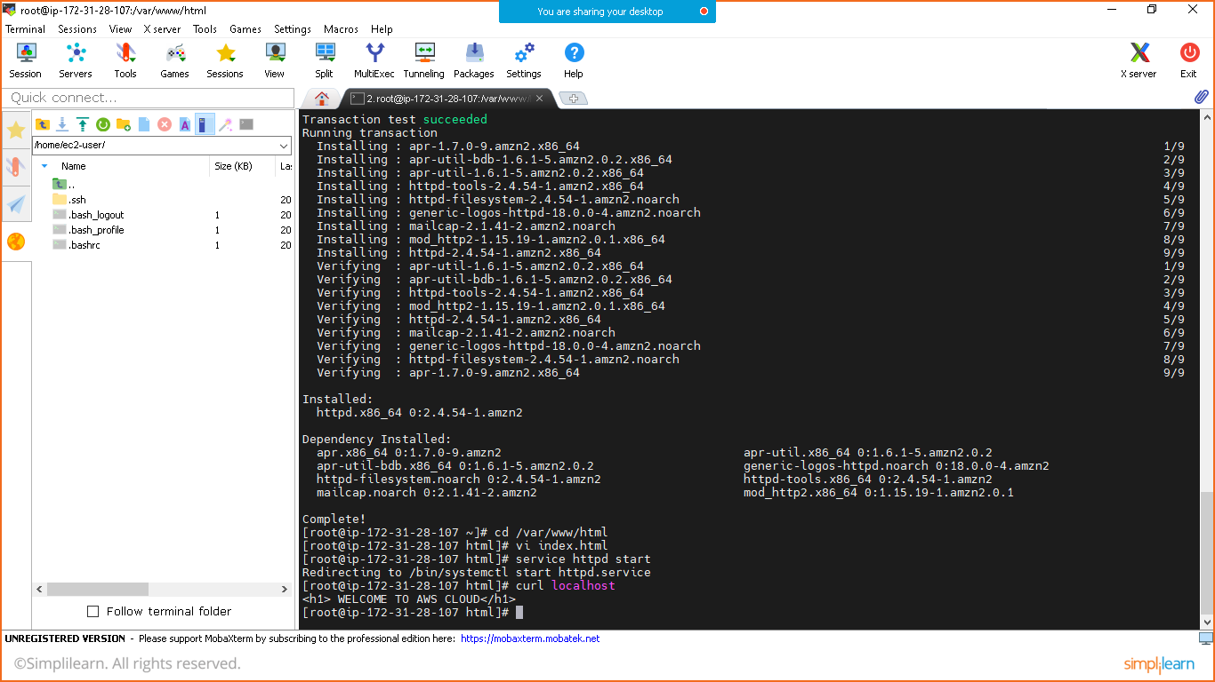

Goto>AWS EC2 Instance>copy public ip:port no

